.W6-HW – Toy AES Cipher
Instructions:
Do not delete or alter any text or questions in this document.
Answer all questions directly below each question.
Show all work for calculation-based questions.
Answer all questions in complete sentences with sufficient detail.
Do not use Bold font for your answers, I have put questions in bold so I can distinguish your response. Do not use bold fonts in your answer. You can use underline or italics.
Q1. (20 points)
Define and explain the following terms in the context of AES:
a) State – Internal data path that holds the block being encrypted and is arranged as a 4x4 matrix of bytes.
b) Substitution–Permutation Network (SPN) – A cipher design that repeats rounds with substitution and permutation/diffusion and the key added in. AES follows this every round.
c) Confusion – When the cipher makes the connection between the key and ciphertext difficult to understand and predict.
d) Diffusion- A small change in the PT causes a large spread over the course of many rounds, causing patterns to be unrecognizable.
e) Round Function – The set of steps that AES applies to the state in a single round.
For the remaining questions, you will work with a simplified AES-like block cipher using 16-bit blocks. This cipher is for learning purposes only and is not secure, but it will help you understand how AES works.
Toy Cipher Description:
Block size: 16 bits (4 nibbles)
State representation: 2 × 2 matrix of 4-bit nibbles (column-major)
Rounds: 2 rounds
Operations used:
• Substitution (Confusion)
• ShiftRows (Diffusion)
• MixColumns (Diffusion)
• AddRoundKey (Key mixing)
Initial AddRoundKey is applied before Round 1. In our case K₀ will be our initial round key. This involves the combination of the data block known as the State with a round key derived from the original encryption key. The operation is relatively straightforward—a bitwise exclusive OR (XOR) is performed between the State and the round key.
Final ( for us the second round) round omits MixColumns.
We will encrypt using the following data:
Plaintext (P): 0x3A94 Or in binary 0011 1010 1001 0100
Round Keys:
K₀ = 0x1F2C or in Binary 0001 1111 0010 1100
K₁ = 0xB6D1 or in Binary 1011 0110 1101 0001
K₂ = 0x0C7E or in Binary 0000 1100 0111 1110
Q2. State Construction (10 points)
Convert the plaintext P into four 4-bit nibbles.
1. Write the four plaintext nibbles.
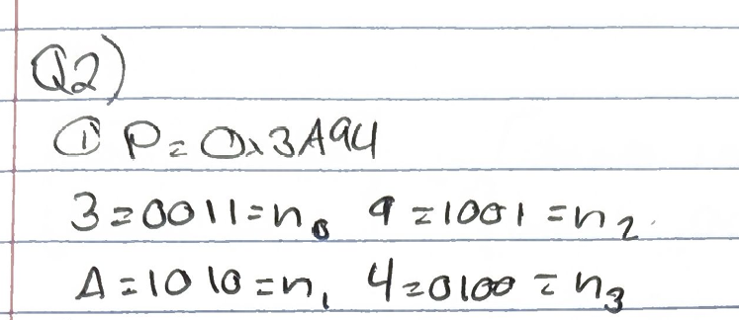

2. Place the nibbles into the 2 × 2 state using column-major order.
Show the resulting state matrix.
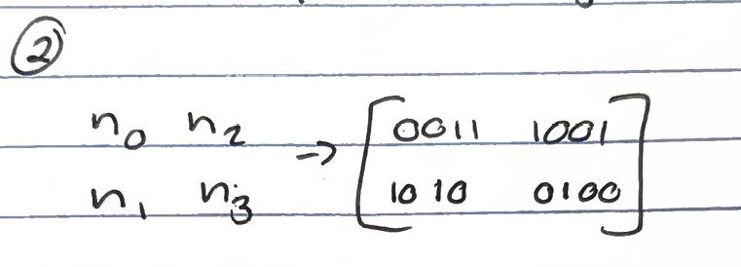

Q3. Initial AddRoundKey (10 points)
Apply AddRoundKey using K₀.
1. XOR each state nibble with the corresponding key nibble.
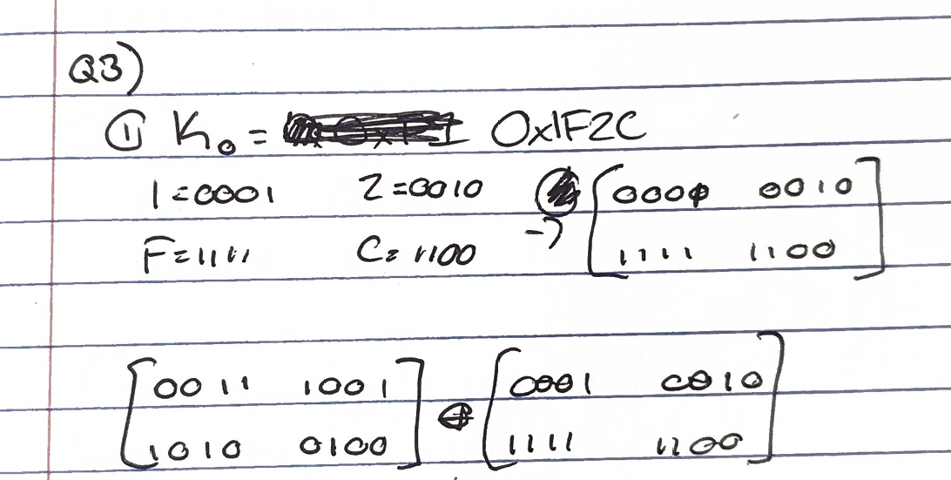
2. Show the resulting state.
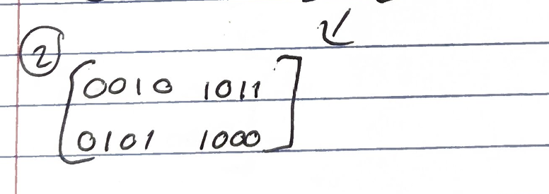
Q4. Round 1 – Substitution Layer (15 points)
Apply the SubNib ( this is same as subbyte but since we are using nibbles we call this step SubNib) operation using the provided S-box.
Row \ Col | 00 | 01 | 10 | 11
00 | 1100 | 0101 | 0110 | 1011
01 | 1001 | 0000 | 1010 | 1101
10 | 0011 | 1110 | 1111 | 1000
11 | 0100 | 0111 | 0001 | 0010

Row = first two bits and Column = last two bits
Example: Input is 1100
First two bits are 11 row 11 is selected
Last two bits are 00 col 00 is selected.
So the S-box substitution is 0100 for nibble 1100.

1. Substitute each nibble in the state and show the resulting state.
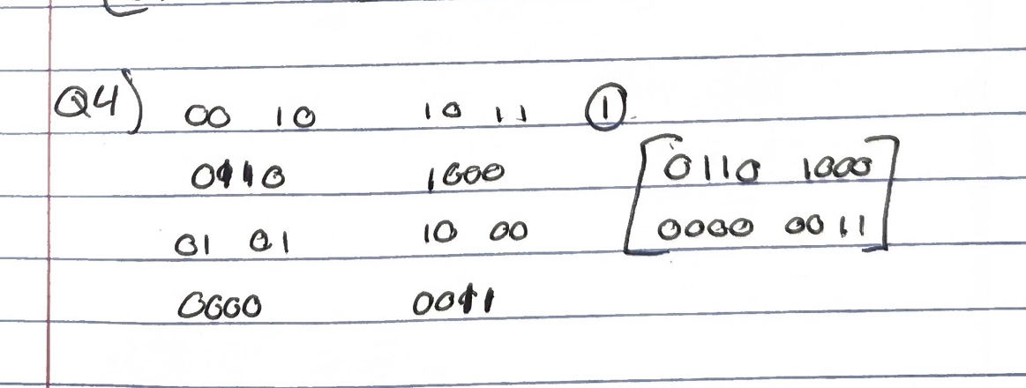
Q5. Round 1 – ShiftRows (10 points)
Apply the ShiftRows operation using the following rules. No shift for first row, one left shift for the second row.
Show the state after ShiftRows.
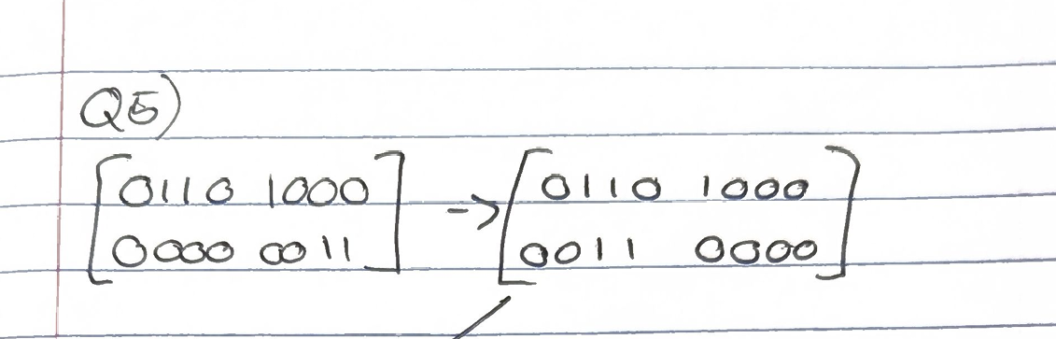
Q6. Round 1 – MixColumns (10 points)
Apply the MixColumns operation to each column of the state using the following rule interchange the cols.
Show the resulting state after MixColumns.
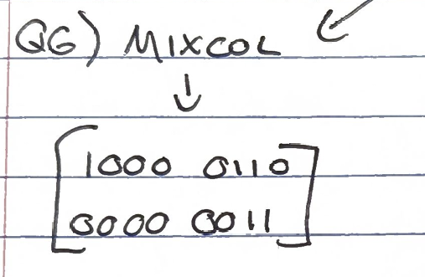
Q7. Round 1 – AddRoundKey (10 points)
Apply AddRoundKey using K₁.
Show the resulting state.
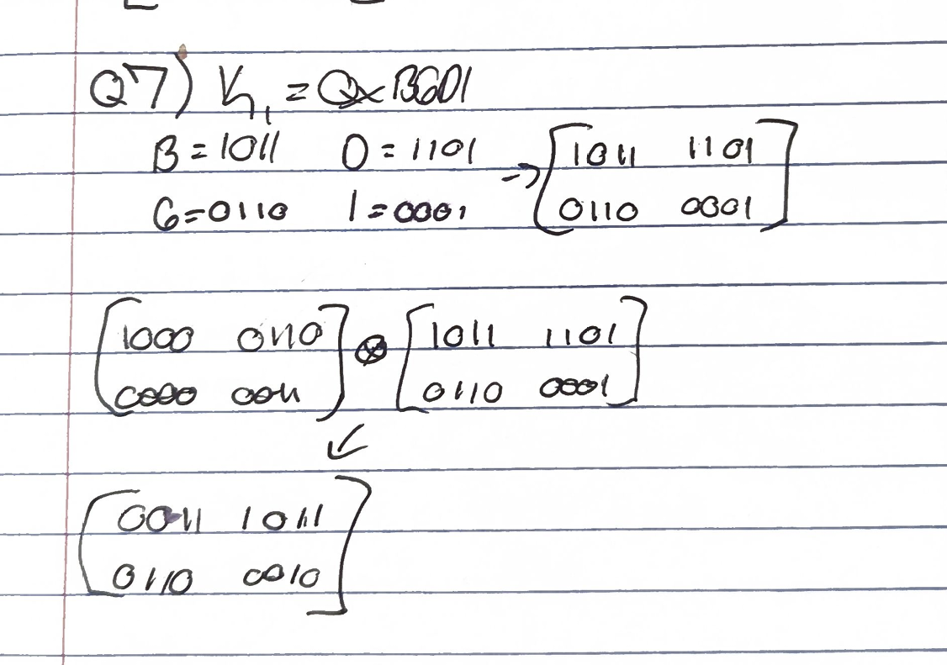

Q8. Final Round (15 points)
Perform the final round of encryption. Use the rules as stated in the first round.
1. Apply SubNib.
2. Apply ShiftRows.
3. Apply AddRoundKey using K₂.
Show the state after each step.
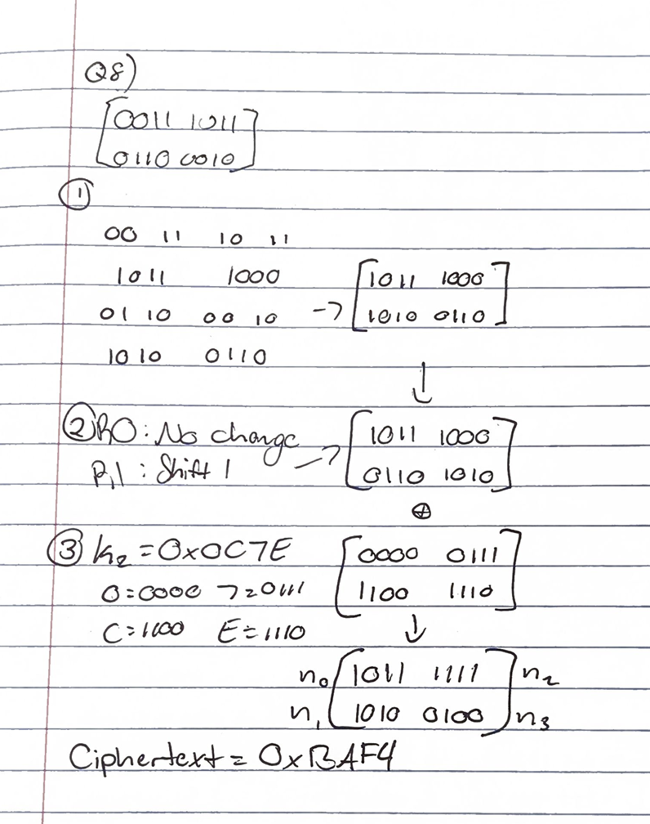
Write the final ciphertext in hexadecimal form.
Q9. 15 points
Flip one bit in the plaintext and repeat only Round 1.
- Show the results.
After subbyte =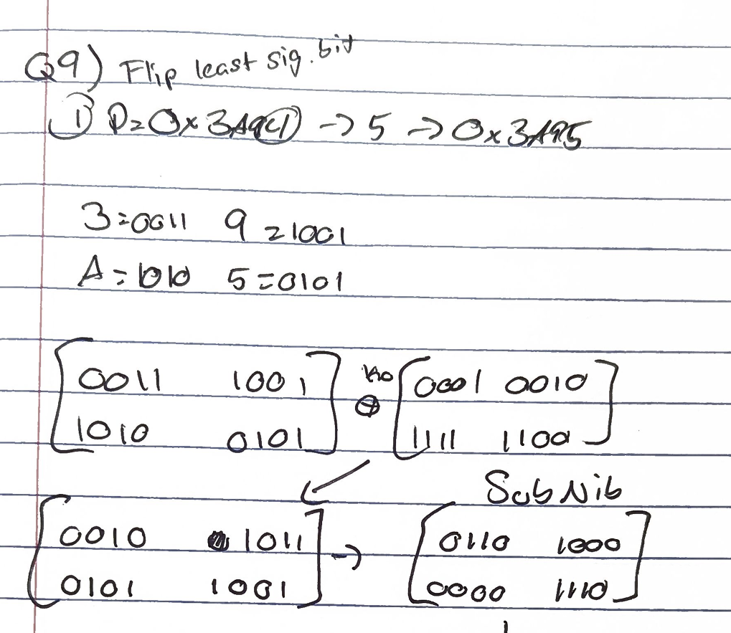

After Shiftrows=
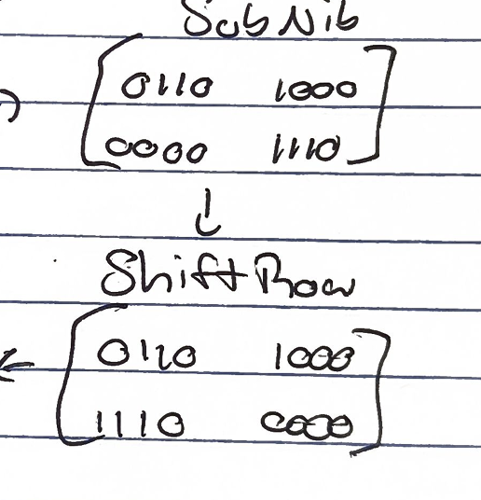
After Mixcols=
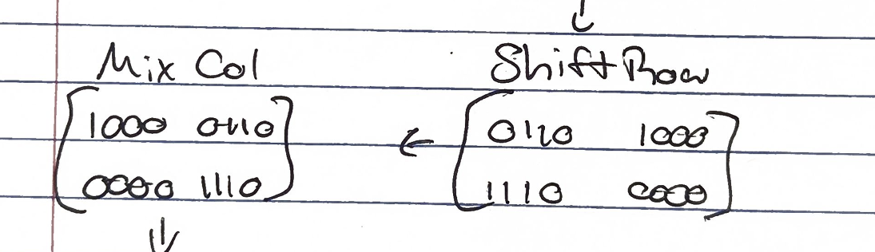
After RoundKey=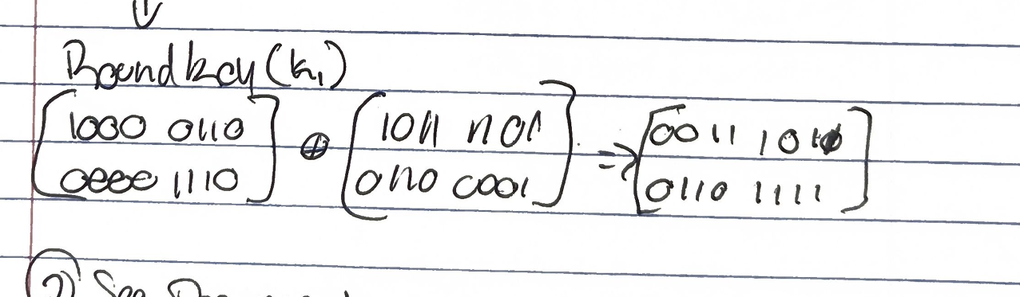
- How many nibbles changed after Round 1?
1 Nibble changed after Round 1 (n3). Changed from 0010 to 1111.

- Explain how ShiftRows and MixColumns contribute to diffusion. Use your result of part 1 to explain your answers,
Shift rows helps diffusion by moving rows of nibbles to different positions. MixColumns does the same but for columns instead of rows. Both of these changes combined results in changes not staying isolated and spreads small inputs across the state.
Q10. 5 points
Explain why the diffusion layer in AES is linear, but must be combined with a non-linear substitution layer to provide security.
The diffusion layer in AES is linear because its operations follow a predictable pattern. If AES only used linear operations, the cipher could be easily reversed which makes it more vulnerable to attack. When combined with the nonlinear layers (S-box’s) it breaks the mathematical predictability of the pattern, making it much harder for attackers to break the cipher.

